Anesthesia Answers Toolkit

Social media content assets
Last modified: October 1, 2026

I. Overview

How to use this content
The materials in this section are ready-to-use social media assets designed to help AANA members, state and regional association leaders, and allied partners promote Anesthesia Answers across their professional and personal social media accounts.

Who this is for
AANA members, state and regional association leaders, allied partners, and anyone championing Anesthesia Answers within their organization or network.

Where you can use it
These assets are designed to work across a range of social media channels:

- Facebook posts
- Instagram posts and captions
- LinkedIn posts and articles
- X (Twitter), Bluesky, or Threads posts
- Any other social platform where you have a professional or organizational presence

How to use it
Assets are designed to mix and match. Pair a caption with a graphic, add a call-to-action, and post. You can use assets as-is or adapt the language to fit your voice, as long as the core message stays accurate and on-brand.

For best results, every post should include:

- A caption or hook
- A graphic or image
- A call-to-action with the URL

A few guidelines
- Tag AANA where possible to help extend reach, especially when referencing “AANA” within post content. Tagging AANA lends the post credibility and indicates ownership.
- Facebook: @AmericanAssociationofNurseAnesthesiology
- Instagram: @aanaphotos
- LinkedIn: @aana
- Use approved graphics only. Do not alter or reformat provided images or logos. In addition, please do not:
- Stretch, squash, or distort proportions
- Change the logo colors or apply filters, effects, gradients, or outlines
- Rearrange, remove, or modify elements
- Add shadows, textures, or other visual treatments
- If you include the URL within your post text, delete the auto-generated link preview card that populates—then post. This improves reach on LinkedIn in particular.
- Do not make claims about Anesthesia Answers that aren't reflected in these materials.
- For questions about approved language or usage, contact AANA at anesthesiaanswers.org/contact-us.

Support
Need help selecting, downloading, or publishing the assets from the toolkit? Submit a contact form at anesthesiaanswers.org/contact-us.

II. Assets
All copy and image assets are ready to use as-is or adapt for your needs.
- Text: Copy and paste any copy asset directly from this document into your platform, tool, or document of choice.
- Images: To save any graphic, click its “Download” link to access the source file on the Anesthesia Answers website. Then, right-click the image and select "Save image as" to save the file to your computer. Images are provided as high-resolution JPGs suitable for both digital and print use.

Copy

Platform | Length | Copy/caption
Facebook | Long form | We’re excited to share a new resource from AANA: Anesthesia Answers.  Whether your patients are preparing for a colonoscopy, navigating pain relief options during pregnancy, or facing any procedure involving anesthesia or sedation, Anesthesia Answers gives them clear, credible information straight from the experts who deliver anesthesia care every day.  Share it, bookmark it, and help us get it in front of the patients who need it most. Visit anesthesiaanswers.org.
Facebook | Long form | Your patients have anesthesia questions. Now there's a place to send them.  Anesthesia Answers is a new patient education website created and vetted by CRNAs/nurse anesthesiologists that gives patients clear, evidence-based answers in plain language, before they ever walk into a procedure room.  Visit anesthesiaanswers.org and share with your network.
Facebook | Long form | Prepared patients are safer patients.  Anesthesia Answers is a new resource from AANA that helps patients understand their anesthesia care before, during, and after any procedure—created by the CRNAs/nurse anesthesiologists who deliver that care every day. It's open to all, easy to navigate, and designed for every patient, everywhere.  Check it out and pass it on: anesthesiaanswers.org.
Facebook | Short form | Your patients have anesthesia questions. Anesthesia Answers has them covered. Visit anesthesiaanswers.org.
Facebook | Short form | Help your patients go into every procedure informed and confident. Explore Anesthesia Answers at anesthesiaanswers.org.
LinkedIn | Long form | AANA has launched Anesthesia Answers, a new patient education website created and vetted by CRNAs/nurse anesthesiologists. Designed to demystify the anesthesia experience, it gives patients clear, evidence-based answers to their most common anesthesia questions in plain language, before they walk into a procedure room.  As healthcare professionals, we know how much it matters for patients to arrive informed and prepared. This is a resource worth sharing with your patients, your colleagues, and your network.  Explore it at anesthesiaanswers.org.
LinkedIn | Long form | Patient safety starts with patient education.  Anesthesia Answers is a new resource from the American Association of Nurse Anesthesiology that gives patients direct, credible answers to their anesthesia questions—created by the CRNAs/nurse anesthesiologists who deliver anesthesia care every day. Whether you're a clinician, a healthcare administrator, or a patient advocate, this is a resource you can share with confidence.  Visit anesthesiaanswers.org.
LinkedIn | Long form | How often do your patients arrive at a procedure with unanswered questions about their anesthesia care?  Anesthesia Answers is here to change that. Developed by AANA and vetted by CRNAs/nurse anesthesiologists, it’s an open-access resource that gives patients clear, evidence-based anesthesia information before any procedure, so they can show up informed, prepared, and confident.  Share it with your patients and colleagues: anesthesiaanswers.org.
LinkedIn | Short form | Anesthesia Answers is a new patient education resource from AANA, created and vetted by CRNAs/nurse anesthesiologists. Share it with your patients and colleagues: anesthesiaanswers.org.
LinkedIn | Short form | Patient safety starts with patient education. Share Anesthesia Answers with your network: anesthesiaanswers.org.

Images
To save any graphic, click its “Download” link to access the source file on the Anesthesia Answers website. Then, right-click the image and select "Save image as" to save the file to your computer.

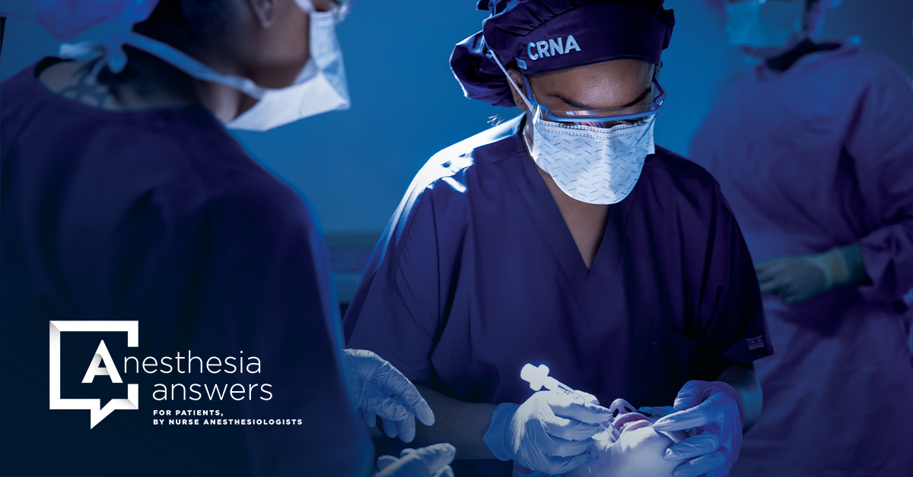  Download Image 1 |   Download Image 2
  Download Image 3 | 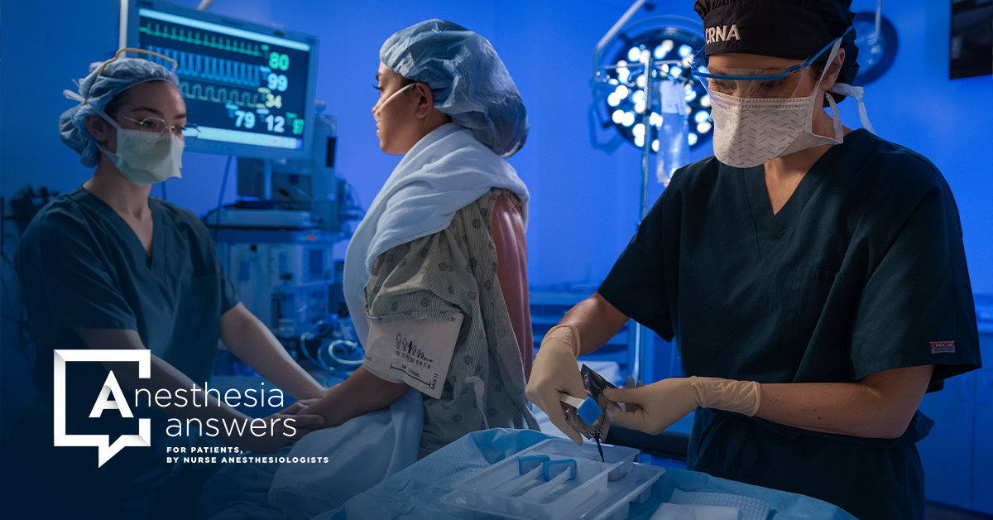  Download Image 4

