Anesthesia Answers Toolkit

Promotional content assets
Last modified: October 1, 2026

I. Overview

How to use this content
The materials in this section are designed to be platform-agnostic, versatile, and ready to use so you can spread the word about Anesthesia Answers wherever your audience is, without starting from scratch.

Who this is for
AANA members, state and regional association leaders, allied partners, and anyone championing Anesthesia Answers within their organization or network.

Where you can use it
These assets are designed to work across a wide range of channels and formats, including:

- Professional and personal social media posts (LinkedIn, Facebook, Instagram, X)
- Website ads, promotions, blog posts, and announcements
- Newsletter announcements and promotional emails
- Press releases and media statements
- Presentation and PowerPoint slides
- Intranet messages and internal communications
- Patient portal content and pre-procedure communications

When working with Anesthesia Answers logos, images, and other assets, use approved graphics only. Do not alter or reformat provided graphics except to re-size or perform light cropping to fit your medium. If cropping, please retain the Anesthesia Answers logo in the frame. In addition, please do not:

- Stretch, squash, or distort proportions
- Change the logo colors or apply filters, effects, gradients, or outlines
- Rearrange, remove, or modify elements
- Add shadows, textures, or other visual treatments

How to use it
Assets are designed to mix and match. Pull a headline, pair it with support copy, and add a call-to-action—that combination works for almost any channel or format. You can use assets as-is or adapt the language to fit your organization's voice, as long as the core message remains accurate and on-brand.

For any communication, try to include at minimum:

- One headline
- One block of support copy
- One call-to-action with the URL or QR code
- One image

Support
Need help selecting, downloading, or publishing the assets from the toolkit? Submit a contact form at anesthesiaanswers.org/contact-us.

II. Assets

All copy and image assets are ready to use as-is or adapt for your needs.
- Text: Copy and paste any copy asset directly from this document into your platform, tool, or document of choice.
- Images: To save any graphic, click its “Download” link to access the source file on the Anesthesia Answers website. Then, right-click the image and select "Save image as" to save the file to your computer. Images are provided as high-resolution JPGs suitable for both digital and print use.

Copy

 | Headlines (choose 1) | Anesthesia answers, straight from the source. |  | Clear anesthesia information for every patient and every procedure. |  | Helping patients go into every procedure informed, prepared, and confident. |  | The anesthesia resource your patients have been searching for. | Better-informed patients start with better information.
 | Support Copy (choose 1) | Anesthesia Answers is a free patient education website created and vetted by CRNAs/nurse anesthesiologists to give patients clear, credible answers to their most common anesthesia questions. |  | Created by the experts who deliver anesthesia care every day. Designed for the patients who deserve to understand it. |  | From colonoscopies to childbirth to pediatric surgery, Anesthesia Answers supports patients across a wide range of procedures—in plain language, backed by real clinical expertise. |  | Anesthesia Answers is a publicly available tool that’s easy to navigate and built on the same commitment to patient safety that CRNAs bring to every procedure. | Clear answers. Credible information. Confident patients.
Calls-to-action (choose 1) |  | Explore Anesthesia Answers |  | Share with your patients |  | Visit anesthesia  answers.org |  | Visit. Explore. Share. | Spread the word
Calls-to-action for Meta & Instagram (fixed) |  | Explore more |  | Learn more |  | See details |  | – | –

Ad hoc copy assets
What it is |  | Free patient education resource created by CRNAs/nurse anesthesiologists | Clear, evidence-based answers to common anesthesia questions |  | Plain language — no unnecessary medical jargon |  | Available to any patient, anywhere, at any time |  | Backed by the American Association of Nurse Anesthesiology
Who it's for |  | Anyone with questions about anesthesia or sedation | Patients facing a first colonoscopy or routine screening |  | Pregnant people navigating pain relief options during labor and delivery |  | Parents preparing for a child's ENT surgery |  | Patients in rural and underserved communities
What it does for patients |  | Answers the most common anesthesia questions before a procedure | Helps patients understand what to expect before, during, and after |  | Reduces anxiety by replacing uncertainty with clear, credible information |  | Empowers patients to take an active role in their own care |  | Builds confidence going into any procedure
Why it's credible |  | Created and vetted by CRNAs/nurse anesthesiologists | Grounded in evidence-based standards and nationally recognized safety protocols |  | Backed by AANA, representing more than 59,000 CRNAs nationwide |  | Free from advertising, sponsorship, or health system affiliation |  | Built on the same clinical expertise CRNAs bring to every patient, every day
How to share it |  | Add the link to pre-procedure patient communications | Feature it in your newsletter, email, or intranet |  | Share it on your professional or organizational social media |  | Post a flyer in your waiting room, break room, or public bulletin board |  | Simply tell your patients: visit anesthesia  answers.org

Images
To save any graphic, click its “Download” link to access the source file on the Anesthesia Answers website. Then, right-click the image and select "Save image as" to save the file to your computer.

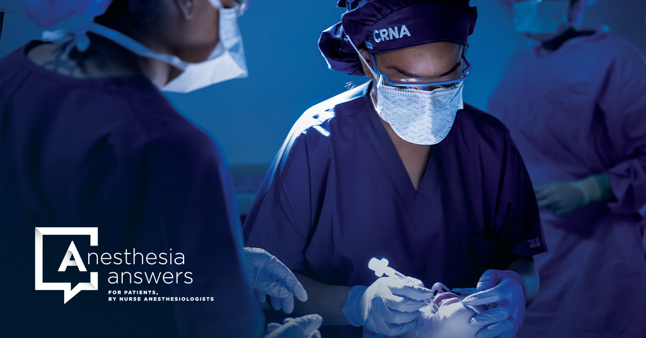  Download Image 1 |   Download Image 2
  Download Image 3 | 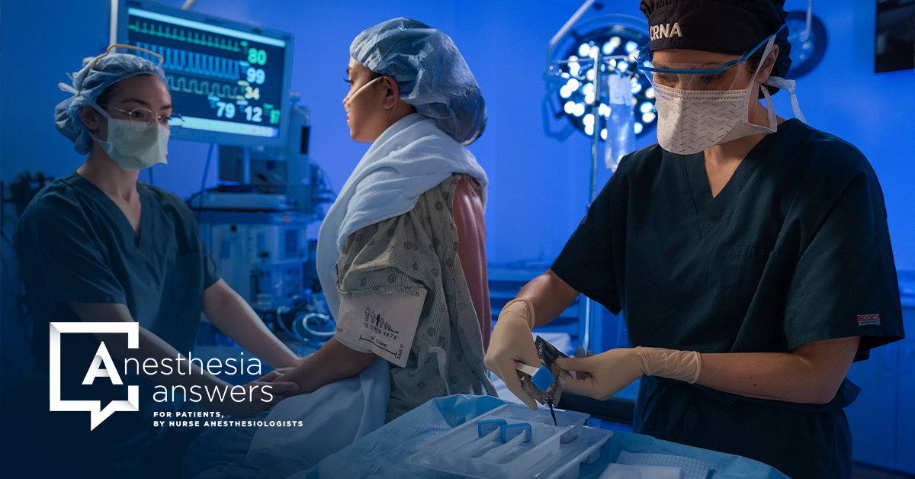  Download Image 4

